Introduction:
- In Terraform each player represents one of four elemental beings. Each elemental being has six destinations to travel to in numerical order. This is your pilgrimage.
- Each round includes a terraform phase, a set phase, and a movement phase.
- The game ends and a winner becomes a God when they travel from destinations 1-5 and back to the start the quickest.

Components:
- One Game Board
- Four elemental beings
  - Circle (4 pieces, Green, Red, Yellow, Blue)
  - Moon (4 pieces, Green, Red, Yellow, Blue)
  - Diamond (4 pieces, Green, Red, Yellow, Blue)
  - Triangle (4 pieces, Green, Red, Yellow, Blue)
- Augmentation Boost Tokens (5 pieces)
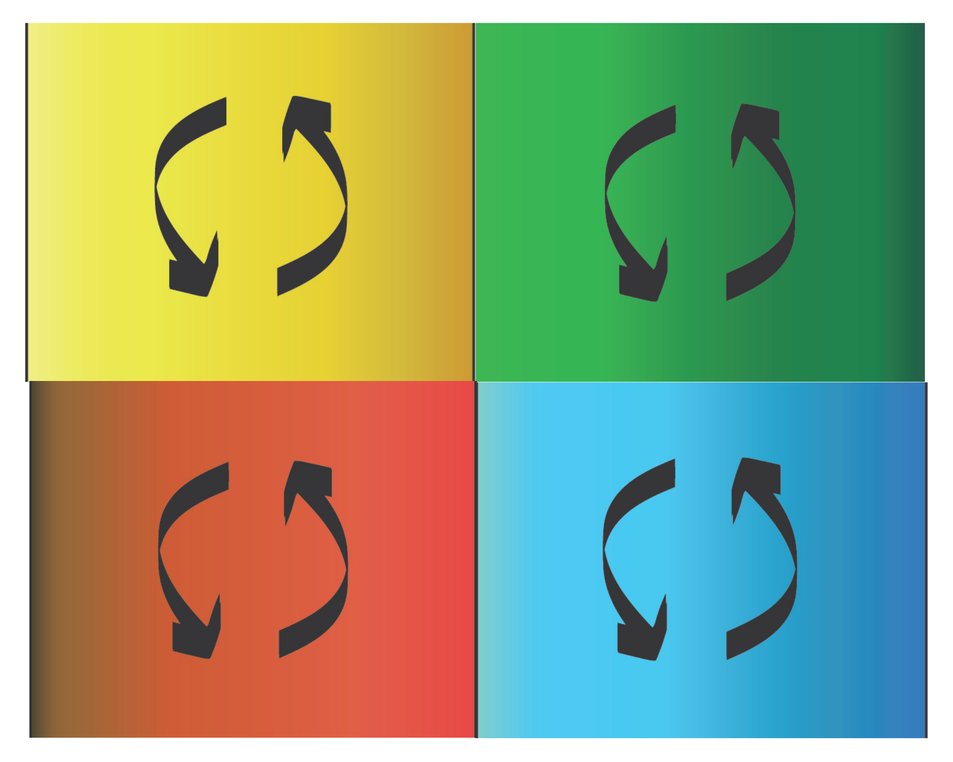
- The Deck
  - Elemental transformation:
    - Green (4 cards)
    - Red (4 cards)
    - Yellow (4 cards)
    - Blue (4 cards)
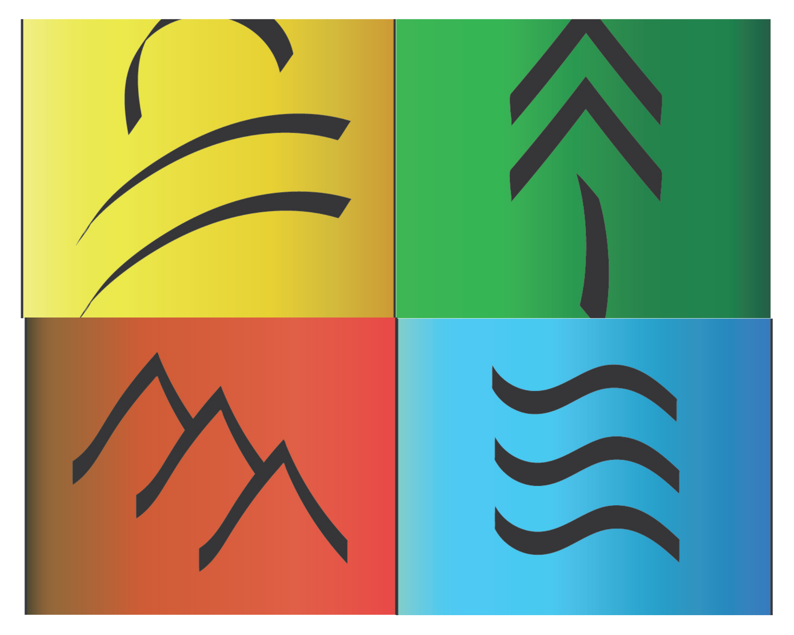
  - Terrain Augmentation:
    - Forest (20 cards)
    - Mountain (20 cards)
    - Desert (20 cards)
    - Lake (20 cards)
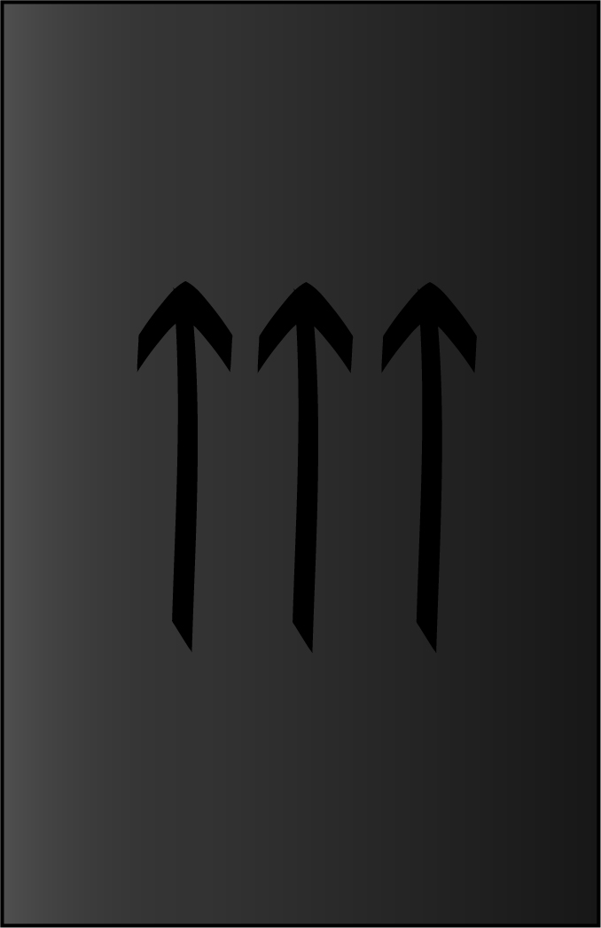
  - Augmentation Boosts:
    - 5
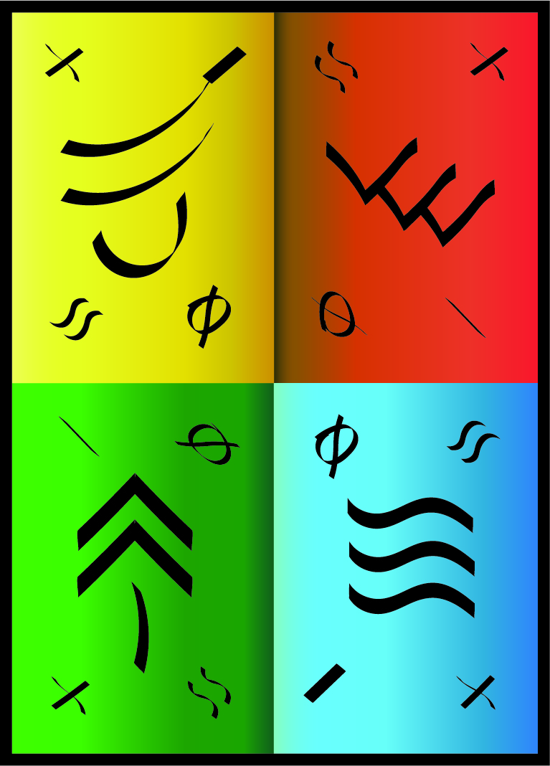

- Legend Board (4)

- Starting Player Token

Set Up:
Each player chooses an elemental being (Circle, Moon, Diamond, Triangle).

First player is chosen and takes possession of the first player token. First player is decided by the person who has played the game the most. If there is a tie, a game of rock paper scissors is played, best 2 out of 3 wins.

Each player is then dealt four cards from the center deck. Deal one card, one player, at a time, starting with the first player.

Once all cards are dealt, each player, starting with the first player, chooses the element (color) they would like to begin with. Place this piece on the corresponding starting place. Then the game starts.

There are three phases in a round.

- Terraforming Phase.
Each player plays a terraforming action placing it tapped on the players chosen spot, starting with player one and moving clockwise. You cannot terraform a space with a tapped terraform card, or occupied by a player. If you have a terraform action you must play it, you cannot skip.

- Set Phase:
Untap cards and replenish each player's cards, starting with player one, one card and one player at a time.

- Movement Phase:
Starting with player one and going clockwise, each player must move their shape the amount of moves allocated depending on your progression across the board. A player cannot end their turn on the same space they started the turn.

After each player completes the movement phase, pass the player one token to the next player in clockwise rotation.

Legend Board
The Legend Board informs each player how the color affects you when stepping onto a terraformed space, depending on what color you currently are. Turn the board so the color you are currently faces you, adjust each time your color is changed.
+ This symbol indicates a plus one movement. As it’s not next to or diagonal from a color, this
$≈$ This symbol indicates a neutral effect when you step onto the color that is to the right of this symbol.
- This symbol indicates a negative one movement when you step onto the color that is to the left of this symbol.
⏀This symbol indicates a block effect when you step onto the color that is diagonal to this symbol.
Example: If you are currently blue, if you were to step onto a space that has a water terrain augmentation card

Rules
- You cannot enter a space another player occupies.
- A card affects a player only once per movement phase. If you land on a terraformed space, it will affect you immediately at the start of your movement phase.
- A space can only be terraformed once per round.

Destination Achievements (Each destination takes effect immediately and for the following phases and rounds.)
- Additional action in the terraform phase. (2T 2M)
- Additional move in the movement phase. (2T 3M)
- Additional action in the terraform phase & additional card (3T 3M)
- Additional move for movement phases. (3T 4M)
- Ability to immediately change to a color of your choice. (3T 4M)

 | Start | Location 1 | Location 2 | Location 3 | Location 4 | Location 5
Moves | II |  | I |  | I | Color Change
Actions | I | I |  | I
Cards |  |  |  | I
Total Cards in the Field | 4 | 4 | 4 | 5 | 5 | 5
Total Abilities | 2 Moves, 1 action | 2 Moves, 2 actions | 3 Moves, 2 Actions | 3 moves, 3 actions | 4 Moves, 3 actions | 4 moves, 3 actions

Rules that need to be added somewhere:

Negative terrain does not affect your movement until you try to leave that terrain. (i.e. if you have one movement left, you CAN move onto a -1 terrain).

If you are transformed into a color while on a terrain that blocks that color, you are stunned, and cannot move during your next movement phase.

You may move diagonally, this costs two movement.

Boosts in general.

Each space may only have up to one boost on it at a time.

Bonuses and negatives only affect each player one time per movement round.

Starting on a space that drops you to zero movement stuns you for one movement phase. You are able to move out with no negative effects in the following movement phase.

CAN change a players color multiple times per terraform phase.

(editor’s thoughts)
-Green and yellow terraform cards should be more visually distinct
-Consider making color pairs instead of a wheel?
-Symbols on each side of board, corresponding with player sitting on that side, to keep track of which player is which shape
-Consider making cards square, so tapped don’t interfere with neighboring cards as much
-Boosts falling off over time? Or when they get terraformed again?
-Limited area of influence?

